## **PROJECT REPORT**

## **ResolveNow – Online Complaint Management System**

### 1. INTRODUCTION

#### 1.1 Project Overview

ResolveNow is a web-based complaint management platform designed to help users easily register, track, and resolve complaints. It streamlines the entire process by providing dashboards for users, agents, and administrators, enabling transparent and efficient complaint handling.

#### 1.2 Purpose

The purpose of ResolveNow is to digitize complaint management, reduce resolution time, and improve transparency. It empowers users by allowing them to track real-time updates and helps organizations manage and resolve complaints efficiently.

### 2. IDEATION PHASE

#### 2.1 Problem Statement

Manual complaint handling leads to delays, data loss, and poor user satisfaction. There’s a need for an intuitive platform where users can lodge complaints, track them, and receive timely resolutions.

#### 2.2 Empathy Map Canvas

**User (General Public):** - **Says:** “I want to know what’s happening with my complaint.” - **Thinks:** “Will this ever get resolved?” - **Feels:** Frustrated by slow manual processes. - **Does:** Tries calling support or sending emails.

**Agent/Admin:** - **Says:** “I can’t keep track of all complaints manually.” - **Thinks:** “I wish there was a dashboard.” - **Feels:** Overwhelmed. - **Does:** Uses spreadsheets or notes.

#### 2.3 Brainstorming

* User dashboard with complaint status
* Agent dashboard for assigned complaints
* Auto notifications
* Complaint categorization
* Admin analytics panel

### 3. REQUIREMENT ANALYSIS

#### 3.1 Customer Journey Map

| Step | User Action | System Response |
| --- | --- | --- |
| Register | Sign up with email | Confirmation mail & account created |
| Submit | Fill complaint form | Save in DB & notify admin |
| Track | View dashboard | Show status updates |
| Resolution | Complaint resolved | Notify user |

#### 3.2 Solution Requirement

* Functional: Login, submit complaint, update status, admin panel
* Non-functional: Responsive design, secure authentication, scalability

#### 3.3 Data Flow Diagram

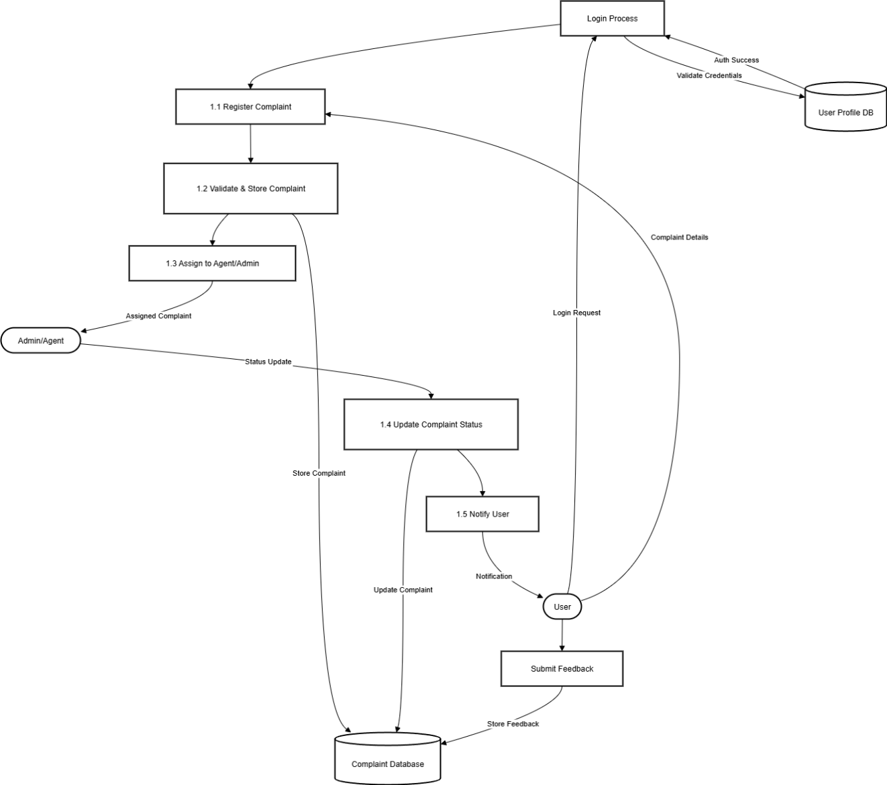

#### 3.4 Technology Stack

* Frontend: React.js + Tailwind CSS
* Backend: Node.js + Express.js
* Database: MongoDB
* Authentication: JWT
* Deployment: Netlify / Vercel / Railway

### 4. PROJECT DESIGN

#### 4.1 Problem Solution Fit

Bridges the gap between users needing transparency and organizations needing centralized complaint management.

#### 4.2 Proposed Solution

A single platform providing dashboards for users, agents, and admins to manage complaints end-to-end.

#### 4.3 Solution Architecture

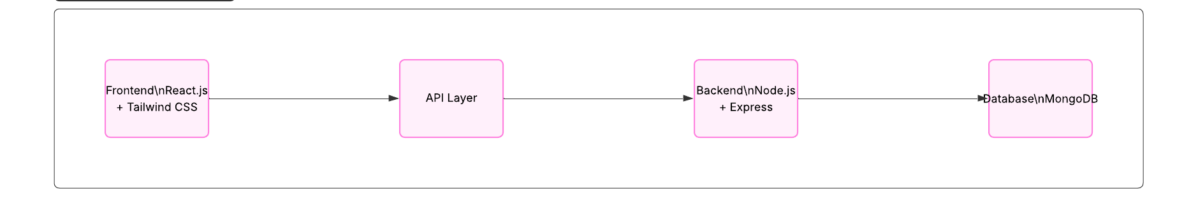Frontend → API Layer → Backend (Node.js / Express) → Database (MongoDB)

### 5. PROJECT PLANNING & SCHEDULING

#### 5.1 Project Planning

| Phase | Task | Timeline |
| --- | --- | --- |
| Ideation & Research | Empathy maps, problem statement | Week 1 |
| Design | Wireframes, architecture | Week 2 |
| Development | Frontend, backend | Week 3-4 |
| Testing | Functional & performance testing | Week 5 |
| Deployment | Hosting & domain setup | Week 6 |

### 6. FUNCTIONAL AND PERFORMANCE TESTING

#### 6.1 Performance Testing

* Load tested API with multiple complaint submissions
* Ensured average response time < 500ms under moderate load

### 7. RESULTS

#### Output Screenshots

* 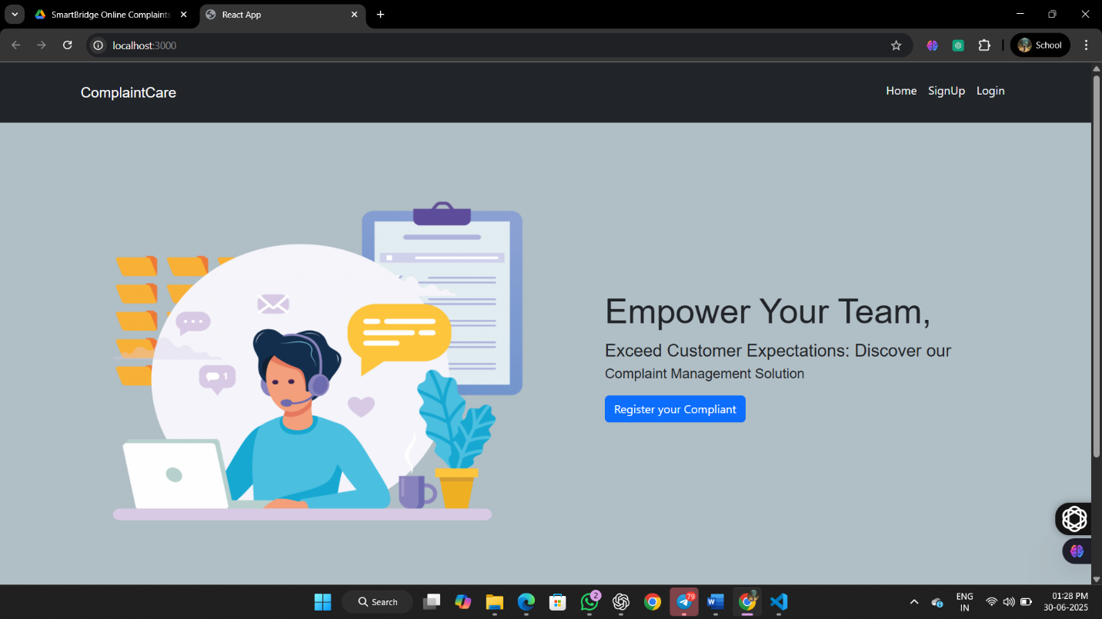**Home Page**
* 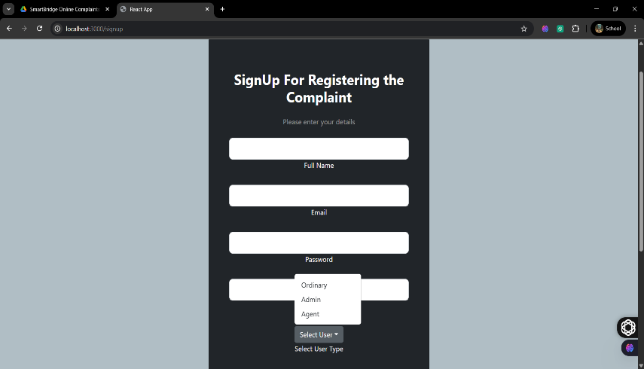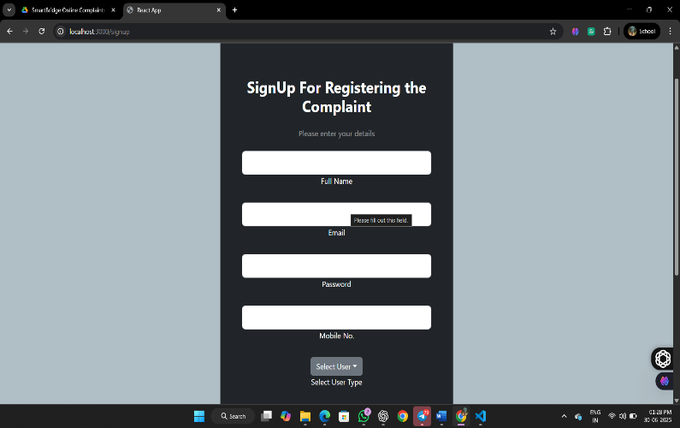**Registration For OnlineComplaint**
* **User Login :** To raise a Complaint

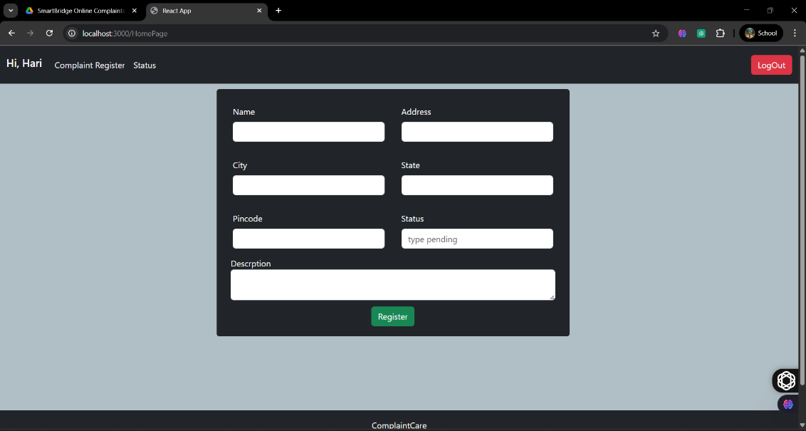

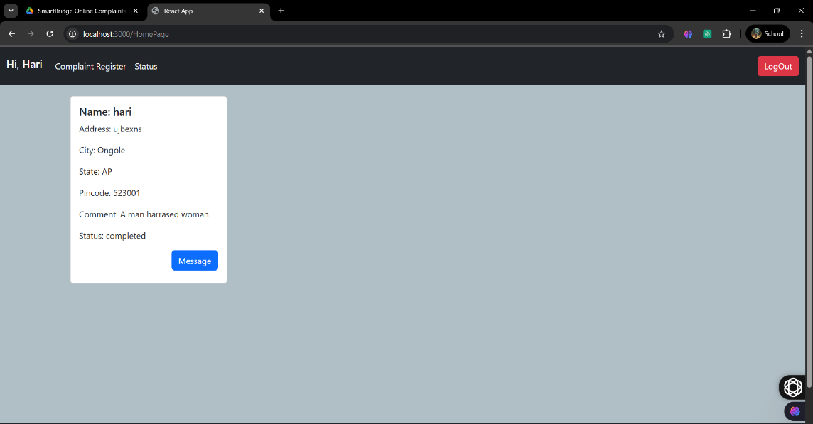

* 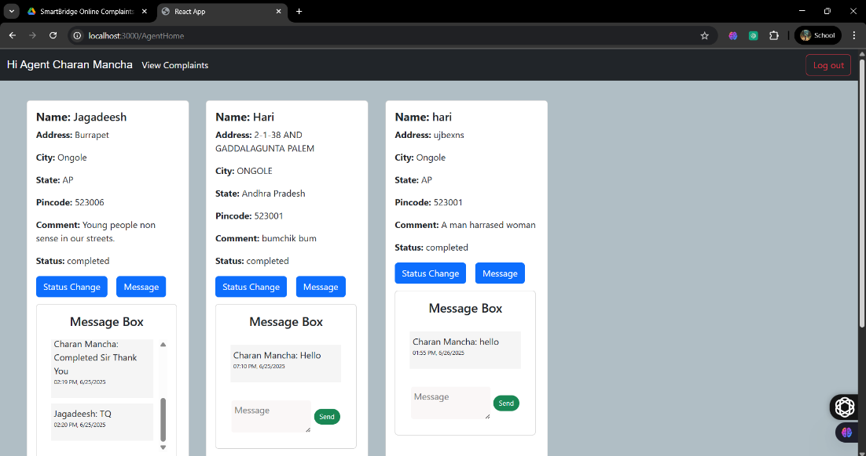**Agent Login**
* 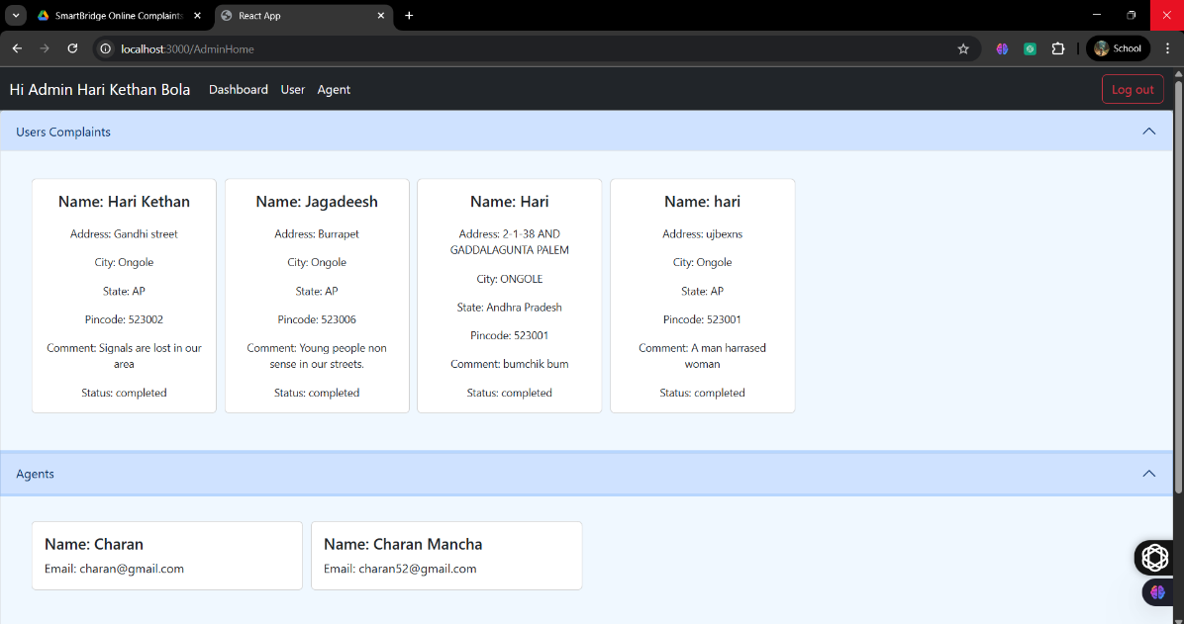**Admin Login**

### 8. ADVANTAGES & DISADVANTAGES

✅ **Advantages:** - Real-time tracking - Transparent process - Easy to use interface

⚠️ **Disadvantages:** - Requires internet access - Initial setup time for organizations

### 9. CONCLUSION

ResolveNow successfully digitizes complaint management, reduces resolution times, and increases user satisfaction by providing a modern, centralized platform.

### 10. FUTURE SCOPE

* Mobile app version
* AI-based auto categorization of complaints
* Real-time chat with agents

### 11. APPENDIX

* **Source Code:** [GitHub Link](https://github.com/HariKethanBola/RESOLVENOW)
* **Dummy Dataset Link :** [Click Here](https://docs.google.com/spreadsheets/d/1EmsLHQQBrxUMyGz1ljSw1RdfzUrAZrgR/edit?usp=drive_link&ouid=115075756600902473315&rtpof=true&sd=true)
* **Project Demo Link:** [Video Demo Link](https://drive.google.com/file/d/1RRF34M8DiE24LamnBjGNdvaJyxojTlgx/view?usp=drive_link)